Newhaven Boat Ramp upgrade  November 2023 | Better Boating Victoria has identified Newhaven as a priority for future upgrades. The concept designs include construction of a third ramp and extending the lanes, replacing the jetty with a gangway and heavy-duty floating pontoon, dredging around the pontoon and an option to create up to (approx) 23 new car and boat trailer parking spaces.
Newhaven Concept Design
Better Boating Victoria (BBV) has prepared a draft concept design to upgrade the public boat ramp at Newhaven. The ramp has limited parking during peak times, limited water depth at lower tides, a deteriorating jetty and a lack of space and configuration of berthing and tie up points. The ramp is an important facility, giving access to Western Port Bay and the narrow entrance at San Remo. The proposed upgrade will offer up to an additional 23 (approx.) car and trailer parking spaces.

What’s been happening?

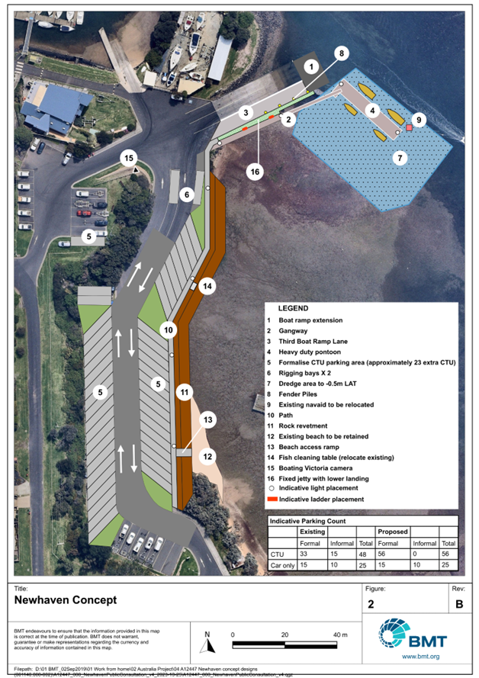
Bass Coast Shire Council commissioned marine consultants to undertake a feasibility assessment of installing a new pontoon at the Newhaven Boat Ramp. However, the project was put on hold due to the poor condition of the jetty. Renewal works were completed in 2022 which included raising of lower deck, replacement of existing upper deck floor and improvements to the substructure.
In early 2023, Better Boating Victoria engaged marine consultants to develop a draft concept design for the future upgrade. In mid-2023, initial meetings were held with a small group of ramp users and local and state government agencies to obtain local input into the concept.

The draft design is now ready for public consultation through an online survey. BBV will also be hosting a drop in event at Newhaven on 7 December 2023.

To review the concept and provide feedback, visit the BBV website at: https://betterboating.vic.gov.au/consultation/

What’s happening next?
After public consultation closes, BBV will review the submitted feedback and where possible incorporate changes to develop a final concept. BBV will then work with the engineers and other government agencies to develop detailed designs and obtain all the appropriate approvals to facilitate future construction of the upgrade.
FAQs (Frequently Asked Questions)
Why is the Newhaven boat ramp getting an upgrade?
The Newhaven boat ramp is an important part of the Victorian boat ramp network, giving access to Western Port just inside of the narrow entrance at San Remo. The facility comprises a two-lane concrete boat ramp, an existing wooden jetty and car parking. The ramp has been identified to receive a future upgrade due to:
- Lack of space and configuration of berthing and tie up points
- Limited car-trailer unit parking – on peak days overflow extends onto surrounding roads
- Insufficient ramp length for launching particularly at low tide
- Existing jetty poses challenges in terms of accessibility
What has happened so far?
Bass Coast Shire Council commissioned marine consultants to undertake a feasibility assessment of installing a new pontoon at the Newhaven Boat Ramp. However, due to the condition of the jetty, the project was put on hold. Renewal works were completed in 2022 which included raising of lower deck, replacement of existing upper deck floor and improvements to the substructure.
In early 2023, Better Boating Victoria engaged marine consultants to develop a draft concept. In mid-2023, initial meetings were held with a small group of ramp users and local and state government agencies to obtain local input.
What are the key features of the concept designs?
Subject to approvals, the design proposes the following improvements:
- Construction of a third boat ramp lane and an extension to the existing ramps by 9 metres to allow for easier access to the water during low tide.
- Existing jetty to be removed and replaced with a new jetty with a lower landing and extended with a gangway and floating pontoon.
- Dredging of the seabed area around the proposed pontoon to allow for boats to dock on either side of the pontoon.
- An additional 23 car and boat trailer parking spaces which requires the reclamation of land on the west side of the existing boat ramp car park to widen the area.
Does the draft concept design include an additional ramp lane?
Yes, the concept design includes one additional lane (taking the total to three lanes) and extending all lanes by up to 9 metres for easier launch and retrieval of vessels, particularly at low tide.
Are there plans to increase the number of car and trailer parks?
Yes. Through reclamation, an additional 23 car and trailer parking spaces would be provided.
What will be involved in the reclamation, if approved?
BBV has commissioned some environmental assessments and, if supported, would seek to reclaim approximately 1,300m2 and rebuild a seawall, to create an extra 23 car trailer parks.

Will the beach be impacted?
The beach at Newhaven to be retained.
Why does the current jetty need to be replaced?
Engineering condition inspections and structural assessments were undertaken in mid-2020. The report identified that the approx. 50-year-old structure is nearing the end of its design life and an upgrade over the next 5-10 years was recommended. BBV awarded funding to Bass Coast Shire Council to carry out urgent repairs to the jetty to ensure it remained operational in the short to medium term. The concept designs developed in 2023 allow for a new jetty with lower landing, new heavy-duty pontoon, which would replace the aging jetty.
Does the proposal include dredging?
Yes. Subject to approvals, dredging will be required to allow suitable depths for vessels. Key environmental assessments and approvals will be required prior to any works commencing.
Where has the funding for this project come from?
Funding for the design is from the Better Boating Fund. The Better Boating Fund was established in 2021 and invests every dollar of marine licensing and boat registration fees to projects and programs that improve boating safety and facilities.
What are the next steps?
Better Boating Victoria is hosting a drop-in session on 7 December 2023 at the Newhaven Boat Ramp for the community to help develop inform the final concept plan. Anyone interested in contributing to the concept should complete the survey found here. After feedback is considered, Better Boating Victoria will finalise the concept and then progress detailed designs and approvals.
To learn more about this project, please visit here. www.betterboating.vic.gov.au
Will we get regular updates to let us know how the project is progressing?
For regular updates and more information please go to: www.betterboating.vic.gov.au

For more information on local boat ramps please visit: FREE Boating Vic app.

Need more information?  Find out more about the government’s recreational boating initiatives at www.betterboating.vic.gov.au | 