Howqua Inlet Boat Ramp  September 2023 | Better Boating Victoria is funding the delivery of a new Howqua Inlet boating facility. The project includes the creation of a concrete dual lane ramp providing high water level access, an adjoining apron with enough room for vehicle turnaround and approx. 20 formal car trailer unit parking spaces.
Howqua Inlet Detailed Design
Better Boating Victoria (BBV) is collaborating with Goulburn Murray Water and Mansfield Shire Council to construct a new public boat ramp at Howqua Inlet on Lake Eildon. There is currently no public boat ramp to access Lake Eildon between the existing boat ramps located at Goughs Bay and Jamieson. The proposed boat ramp will offer an additional option for launching and retrieving at Lake Eildon between 78%-100% water supply level
What’s been happening?
The Victorian Recreational Boating Strategy identified the need for a formalised boat ramp for recreational boaters in the Howqua Inlet region of Lake Eildon. In 2022 Better Boating Victoria funded the delivery of the concept stage which included the identification of a suitable site and public consultation.

Working with BBV and Goulburn Murray Water, Mansfield Shire Council undertook two rounds of community engagement in 2022 and 2023 to identify the preferred site. The engagement results were presented to Councillors in April 2023 and Council endorsed the "Howqua East" proposal.

In June of 2023, BBV engaged engineering firm Partnear to progress detailed construction ready designs for the boat ramp. As part of the design process, a concept design is now ready for public consultation through an online survey.

To review the concept and provide feedback, visit the BBV website at: https://betterboating.vic.gov.au/consultation/

What’s happening next?
After public consultation closes, BBV will review the submitted feedback and where possible incorporate changes into the final designs. BBV will then work with the engineers and other government agencies to obtain all of the appropriate approvals to facilitate future construction of the new boating facility.
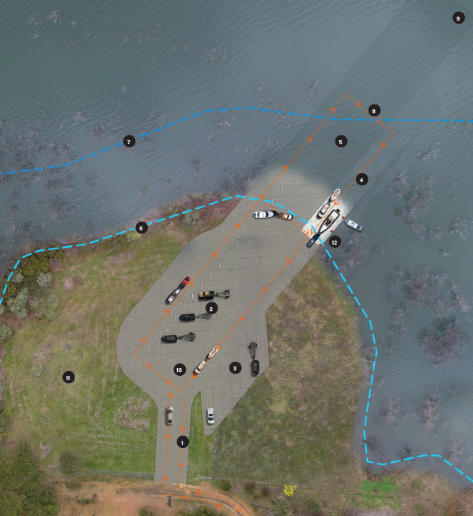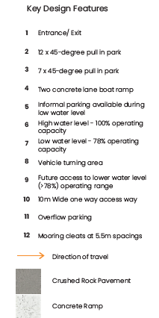
FAQs - Frequently Asked Questions
Why is the Howqua Inlet getting a boating facility?
The Victorian Recreational Boating Strategy identified the need for a formalised boat ramp for recreational boaters in the Howqua Inlet region of Lake Eildon. There is currently no public boat ramp to access Lake Eildon between the existing boat ramps located at Goughs Bay and Jamieson. The proposed boat ramp will offer an alternative option for launching and retrieving at Lake Eildon during 78%-100% water supply level .
What consultation has been completed to determine the location?
Mansfield Shire Council undertook two rounds of community engagement in 2022 and 2023 to identify the preferred site. The engagement results were presented to Councillors in April 2023 and council subsequently endorsed the "Howqua East" proposal.

Where is the boat ramp going to be located?
Mansfield-Woods Point Road at Piries VIC 3723

What is included in the proposed design?
The project includes the creation of a concrete dual lane ramp providing high water level access, mooring rings / cleats will be included on the ramp, an adjoining apron with enough room for vehicle turnaround and approx. 20 formal CTU parking spaces.
Why is there no holding structure or pontoon?
Due to the fluctuating water levels at Lake Eildon, a holding structure is not possible at this location. To enable boaters to secure their vessels when launching and retrieving mooring rings or cleats are being proposed on the ramp.
How much access will this provide to the Lake?
This boat ramp is a high-water supply level ramp that has been designed to provide from 78%-100% water supply level.
What happens when the water level drops below 78%?
This ramp has been designed to be modular so that in the ramp could be extended further out into the lake at lower levels. Consultation was also completed on the option for a low-to-mid-level ramp, and two site options were identified near Howqua. However, due to the current high-water levels, work on the low-to-mid-level ramp will not be possible in the foreseeable future. This planning may occur in the future as a separate project.

How much parking will be made available for boats with trailers?
There will be approx. 20 Car Trailer parks available for recreational boaters to use for parking while out on the water. An informal overflow area will also be available for peak boating days.

Will cultural and environmental values be protected?
Yes, an independent consultant is preparing a Cultural Heritage Management Plan in consultation with the Taungurung Land and Waters Council (TLaWC). Key environmental assessments and approvals will also be completed prior to any works commencing.
What will be the impact on local residents?
The impact on local residents will be minimal as the proposed ramp will be out of the main town of Howqua Inlet. The current proposed plans only include approx. 20 Car Trailer Spaces, and does not include facilities such as public toilets, rubbish bins, shelters, or barbecues as the objective of the ramp is to provide high water level access only.

When is construction likely to start?
The upgrade to the Howqua Inlet boating facility is currently in the design phase with construction expected to occur in 2024-2025, pending obtaining the necessary approvals.
Where can I launch and retrieve my boat if the ramp is unavailable?
The nearest boat ramps include:
- Goughs Bay Boat Ramp
- Jamieson Creek Boat Ramp
For more information on local boat ramps please visit: FREE Boating Vic app.
Will we get regular updates to let us know how the project is progressing?
For regular updates and more information please go to: www.betterboating.vic.gov.au
Need more information?  Find out more about the government’s recreational boating initiatives at www.betterboating.vic.gov.au | 