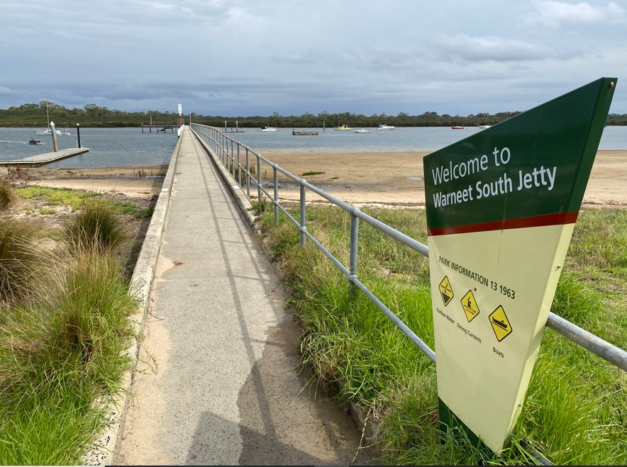
The Warneet Boating Precinct is being upgraded as part of the Victorian Government’s commitment to make boating more accessible for all Victorians.
Warneet Boating
Facility Upgrade
Jetty Update
January 2023
Detailed engineering drawings and an approvals process is currently underway to bring the new jetty projects closer to construction.

What’s happened so far
Final concept plans for the Warneet Boating Precinct were released in December 2021 following extensive consultation with boat ramp users and the community.
The concept designs include plans to upgrade the boat ramp, extend the floating pontoon, formalisation of the main carpark and overflow car parking improvements. Also included are the designs for both Warneet North and Warneet South jetties.
What’s happening right now

The detailed design for both Warneet North and Warneet South jetties is in progress
Stantec (previously known as Cardno), a specialist maritime and civil engineering firm, has been appointed to prepare the designs for both jetties.

Site investigations have commenced
Geotechnical and ecologist teams have visited the site to collect data to guide engineering and construction methodology and minimise impact of construction on the marine environment.

What’s next?
- Detailed engineering designs are in the final stages for both jetties. Preliminary designs were delivered by the end of 2022.
- Planning and environmental permits will be submitted with relevant authorities over coming months
- A Cultural Heritage Management Plan has been commissioned to protect cultural heritage.
- Final ‘ready for tender’ documentation will be completed by mid-year.
- Once detailed designs are complete, Parks Victoria will undertake a final approvals process and commence the process to construct the new jetties.
- Asset managers are responsible for securing funding for asset upgrades. Works shown on this plan may be undertaken in stages

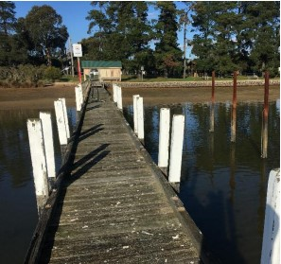
North Jetty
Fact Sheet: Jetties details

sdd

No
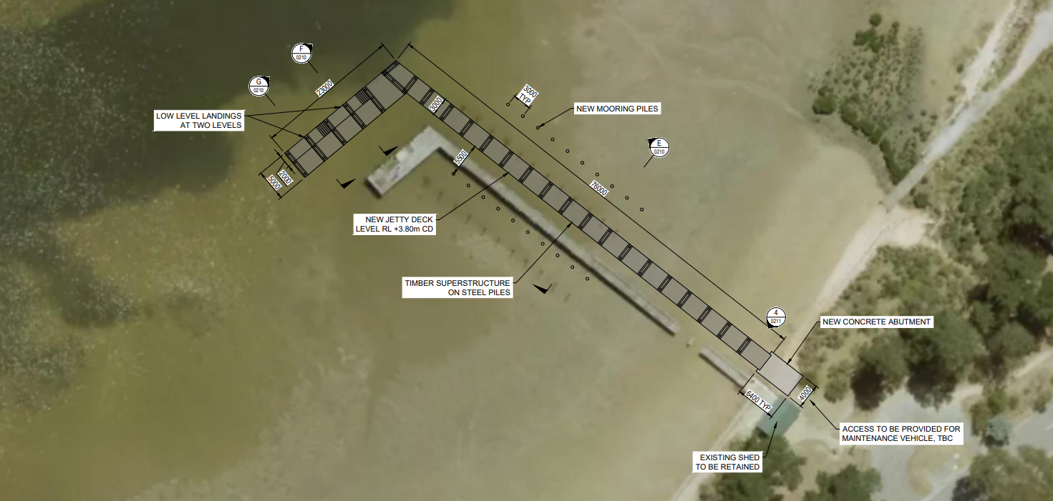

Location | Like for like design with extension into deeper water beside existing jetty
Length | 76m
Width | 3m
Material | Concrete decking and substructure on steel piles
Design life | 50 years
Berthing capacity | Low level landing at 2 levels providing berthing capacity for approx4 vessels. Note: the location is restricted due considerably shallow water
Vehicle access | Restricted access for small emergency and maintenance vehicles
Wheelchair access | Full access for length of jetty.
Fishing | Regularly spaced fishing rod holders
Lighting | Regularly spaced solar lighting
Mooring piles | Mooring piles will be provided
Warneet North Jetty design proposes a bigger and more accessible facility.
The jetty is being designed to be re-built in the same spirit as the existing; constructed with use of timber decking and providing a dual level low landing for boaters and fishers. New piles will be manufactured out of steel to assure an extended design life whilst a new positioning, slightly offset from the existing will provide restricted access to emergency and maintenance vehicles. The existing shed will be retained.
The existing jetty will be removed once construction commences on the new-build; which will be subject to the outcome of the planning process.
The construction stage of the project will be managed and delivered by the facility manager, Parks Victoria as part of the $9.5M allocated by the Victorian Government for both North and South Warneet Jetties. Details including a construction timeline will be provided by Parks Victoria later in the year.

North jetty Design Overview
South Jetty
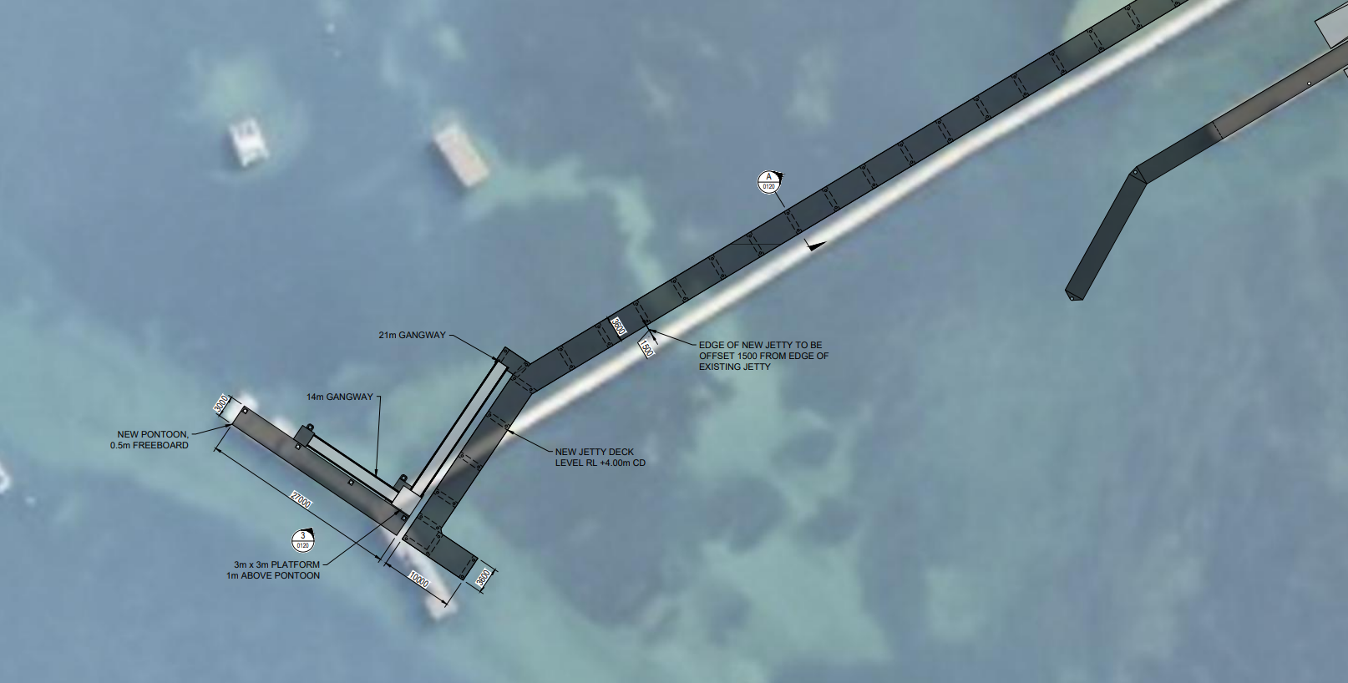

Warneet South jetty has been designed to maximise access to recreational activities for the whole community.
The 200m jetty will be constructed out of prefabricated concrete slabs, providing a width of 3m for pedestrians to access fishing and boating.
The new and improved floating pontoons, located at the end of the jetty will provide all-tide berthing for larger vessels and be accessed by gangways.
The jetty will be fully accessible to all members of the community, with access provided for wheelchair users to the floating pontoon by DDA compliant gangways.
Areas for shore-based fishers to cast a line from the jetty will provided at the jetty head.
The existing jetty will be removed once future construction commences, which will be subject to the outcome of the planning process.
The construction stage of the project will be managed and delivered by the facility manager, Parks Victoria as part of the $9.5M allocated by the Victorian Government for both the South and North Warneet jetties. Details including a construction timeline will be provided by Parks Victoria later in the year.

South jetty Design Overview:
Location | Beside existing jetty
Length | 200m
Width | 3.6m
Material | Timber decking and handrails. Steel piles
Design life | 50 years
Berthing capacity | 27m long floating pontoon to be provided for 4-5 vessels.
Vehicle access | Restricted access for emergency and maintenance vehicles
Wheelchair access | Yes, DDA compliance is met for gradient on ramp& gangway. Wheelchair hoist provided on pontoons
Fishing | Regularly spaced fishing rod holders
Lighting | Regularly spaced solar lighting
Ladders | Regularly spaced along the length of the jetty
Fenders | Regularly spaced along the length of the jetty

Boating Precinct plan
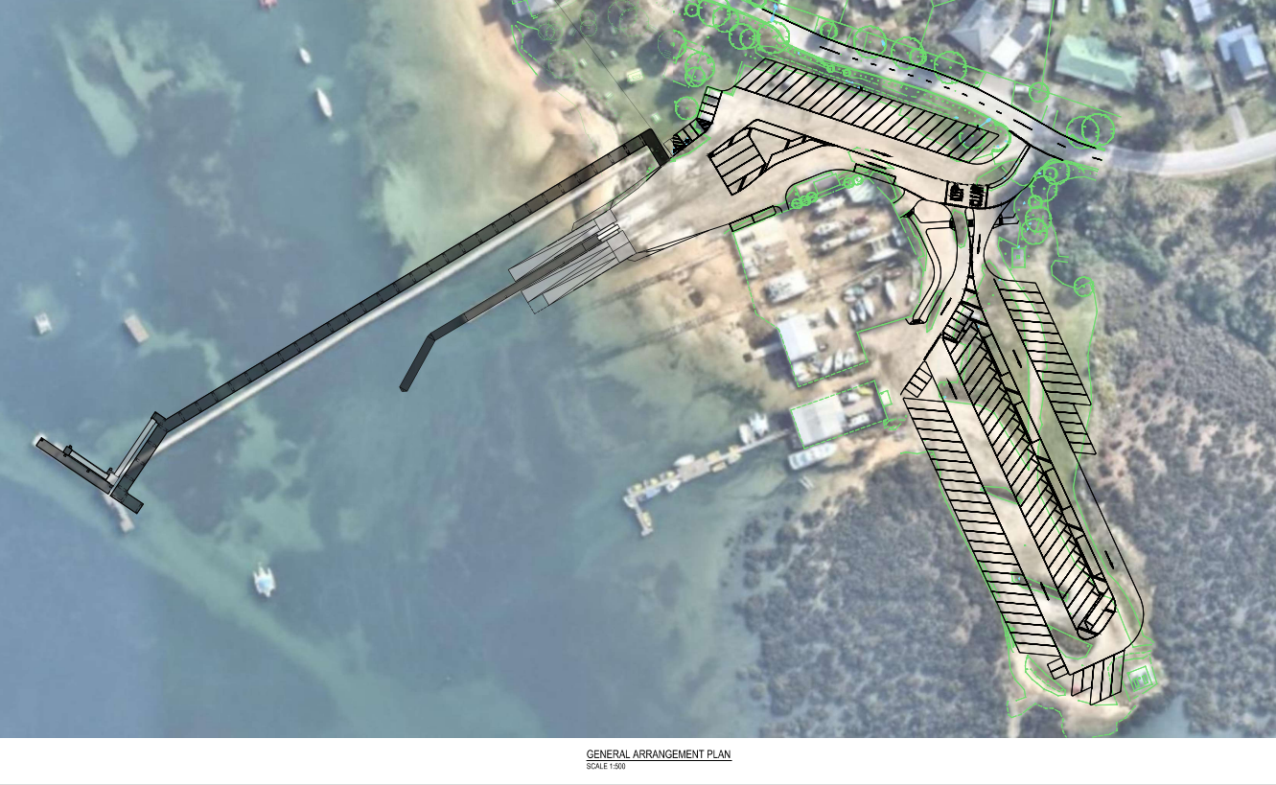

As part of the wider future upgrade to the boating precinct as a whole, detailed designs are being prepared for the boat ramp, floating pontoons and carparking. The design, based on the final masterplan, released to the public in August 2021 incorporates stakeholder feedback to improve facilities for recreational boaters at this location. Proposed improvements include:
- Extension of the floating jetty to improve temporary berthing capacity
- Construction of a compliant third boat ramp to improve efficiency in launching and retrieving vessels.
- An upgrade to the existing main carpark, including asphalting and line marking and improvements to the overflow carpark .
- Further investigations into dredging of the boat ramp channel to provided access during a greater range of tides.

- Inclusion of accessible parking bays and wheelchair accessible footpath access to boat ramp and jetty
Boating precinct Design Overview:
Number of carparks (Car & trailer) | Main carpark: 22  Overflow carpark: 72
Number of carpark (single) | 24
Number of accessible parking bays | 4
Number of boat ramps | 3
Floating pontoon details | 30m extension
Fish cleaning table | Retained
FAQ’s
What do designs for the Warneet Boating facility upgrade include?
The detailed engineering designs for the Warneet Boating precinct upgrade will include designs for the boat ramp upgrade, car park upgrade, both jetties and provision for a toilet block.
Who will be funding construction works?
The Victorian Government has committed $9.5 Million for the construction of the Warneet North and South jetties.
When will the design stage be completed?
Better Boating Victoria (BBV) is working in partnership with Parks Victoria to have a tender-ready pack by mid-2023.

When will this be constructed?
Construction timing of the boat ramp, car park and jetties is to be confirmed. Details on a construction timeline will be provided by Parks Victoria later in the year.
Asset managers are responsible for securing funding for asset upgrades. Works shown on this plan may be undertaken in stages.
Will the Warneet North and Warneet South jetties be re-opened?
An independent engineering assessment of both jetties has determined them to be in poor condition and unsafe for public use. Accordingly, both jetties are closed to public access due to immediate risk of failure.
Who will manage the jetties moving forward?
Parks Victoria will continue to be the asset manager of Warneet North and Warneet South jetty and will manage the construction of the new jetties.
How has the community been consulted?
Better Boating Victoria hosted a community drop-in session in April 2021 and an online consultation process in October 2022 to receive feedback on the draft concept design. 264 responses were received and analysed including 59 from boat ramp users and 70 residents.
What feedback did you receive from the consultation?
Through the online survey and community event, the community said they were supportive of the boating facility upgrade including:
- Increased and formalised parking at the facility.
- Improving, reopening and redeveloping both the Warneet North and Warneet South jetties
- Improved access for those with disabilities
- Including the new toilet block on the foreshore
- Conducting repairs to walking trails
- Increasing the functionality of the overall facility
How will native vegetation be protected?
There is no intention to impact surrounding native vegetation. Vegetation and arborist assessments have been completed and environmental permits and approvals are being sought from relevant agencies. Upgrade works to carparks will stay within the existing footprint.
Will the cultural heritage values be protected?
Yes - BBV are continuing to engage with traditional owners on this project and are collaborating with the Bunurong Aboriginal Land Corporation in preparing a Cultural Heritage Management Plan.
What’s happening in the overflow carpark?
Public feedback during the consultation showed that the informal nature of the overflow car park was appreciated. Permeable grassed and gravel parking bays will be used to identifying and improve parking capacity. Asphalting will be used for the circulation aisle only.
Is a toilet block or fish cleaning table being constructed?
A toilet block is planned to be in the open space between Warneet South jetty and motor yacht club. Funding for a toilet block needs to be sourced and a provision for a future install will be made in the designs and permits. The Fish Cleaning Table is intended to stay in its current position.
Will the boat ramp be more consistently dredged?
A dredge programme is being investigated separate to this project which will consider and plan for regular dredging of the boat ramp and channel.
Where can I find out more?
To follow the next steps and receive updates visit our website at: www.betterboating.vic.gov.au/ramp-upgrades/warneet-boating-precinct/

